**Prep:**

5 mins

**Total:**

20 mins

**Servings:**

4

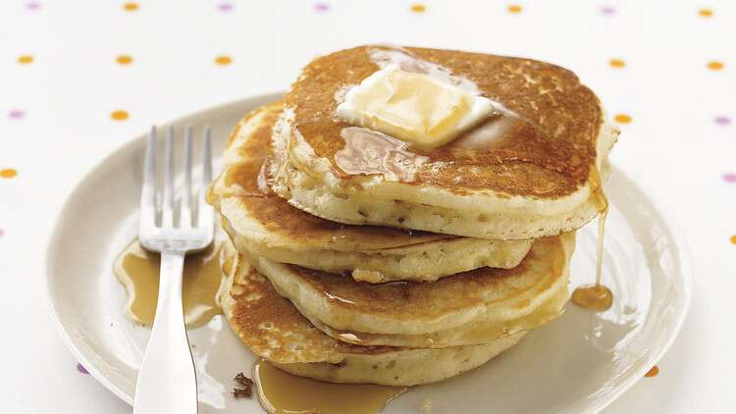

Ingredients

Ingredient Checklist

* 1 cup all-purpose flour, (spooned and leveled)
* 2 tablespoons sugar
* 2 teaspoons baking powder
* 1/2 teaspoon salt
* 1 cup milk
* 2 tablespoons unsalted butter, melted, or vegetable oil
* 1 large egg
* 1 tablespoon vegetable oil
* Assorted toppings, such as butter, maple syrup, confectioners' sugar, honey, jams, preserves, sweetened whipped cream, or chocolate syrup

Directions

Instructions Checklist

* **Step 1**

Preheat oven to 200 degrees; have a baking sheet or heatproof platter ready to keep cooked pancakes warm in the oven. In a small bowl, whisk together flour, sugar, baking powder, and salt; set aside.

* **Step 2**

In a medium bowl, whisk together milk, butter (or oil), and egg. Add dry ingredients to milk mixture; whisk until just moistened (do not overmix; a few small lumps are fine).

* **Step 3**

Heat a large skillet (nonstick or cast-iron) or griddle over medium. Fold a sheet of paper towel in half, and moisten with oil; carefully rub skillet with oiled paper towel.

* **Step 4**

For each pancake, spoon 2 to 3 tablespoons of batter onto skillet, using the back of the spoon to spread batter into a round (you should be able to fit 2 to 3 in a large skillet).

* **Step 5**

Cook until surface of pancakes have some bubbles and a few have burst, 1 to 2 minutes. Flip carefully with a thin spatula, and cook until browned on the underside, 1 to 2 minutes more. Transfer to a baking sheet or platter; cover loosely with aluminum foil, and keep warm in oven. Continue with more oil and remaining batter. (You'll have 12 to 15 pancakes.) Serve warm, with desired toppings.

Pancake Variations

* **Step 1**

BUTTERMILK: In step 1, add 1/2 teaspoon baking soda to dry mixture. In step 2, replace the milk with low-fat buttermilk.

* **Step 2**

YOGURT: In step 1, add 1/2 teaspoon baking soda to dry mixture. In step 2, replace the milk with 2/3 cup plain low-fat yogurt and 1/3 cup milk.

* **Step 3**

WHOLE-GRAIN WITH YOGURT: In step 1, replace the all-purpose flour with 1/2 cup whole-wheat flour, 1/4 cup each cornmeal and wheat germ, and 1/2 teaspoon baking soda. In step 2, replace the milk with 2/3 cup plain low-fat yogurt and 1/3 cup milk.